`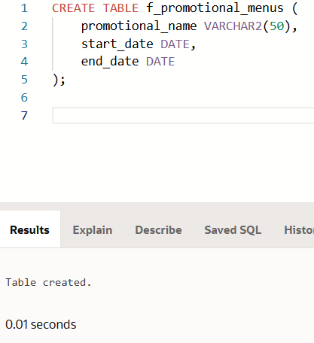

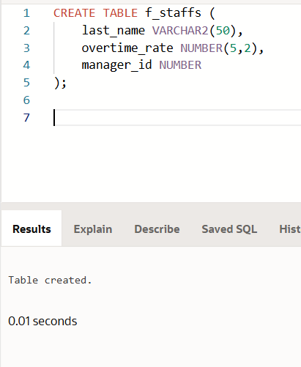

**INSERT INTO f_promotional_menus (promotional_name, start_date, end_date) VALUES ('Summer Special', TO_DATE('2024-06-01', 'YYYY-MM-DD'), TO_DATE('2024-07-01', 'YYYY-MM-DD'));

**INSERT INTO f_promotional_menus (promotional_name, start_date, end_date) VALUES ('Winter Feast', TO_DATE('2024-12-01', 'YYYY-MM-DD'), NULL);

**INSERT INTO f_staffs (last_name, overtime_rate, manager_id) VALUES ('Smith', 10.00, 1001);

CREATE TABLE f_staffs (

last_name VARCHAR2(50),

overtime_rate NUMBER(5,2),

manager_id NUMBER

);

INSERT INTO f_staffs (last_name, overtime_rate, manager_id) VALUES ('Smith', 10.00, 1001);

INSERT INTO f_staffs (last_name, overtime_rate, manager_id) VALUES ('Johnson', NULL, 1002);

INSERT INTO f_staffs (last_name, overtime_rate, manager_id) VALUES ('Brown', NULL, NULL);

